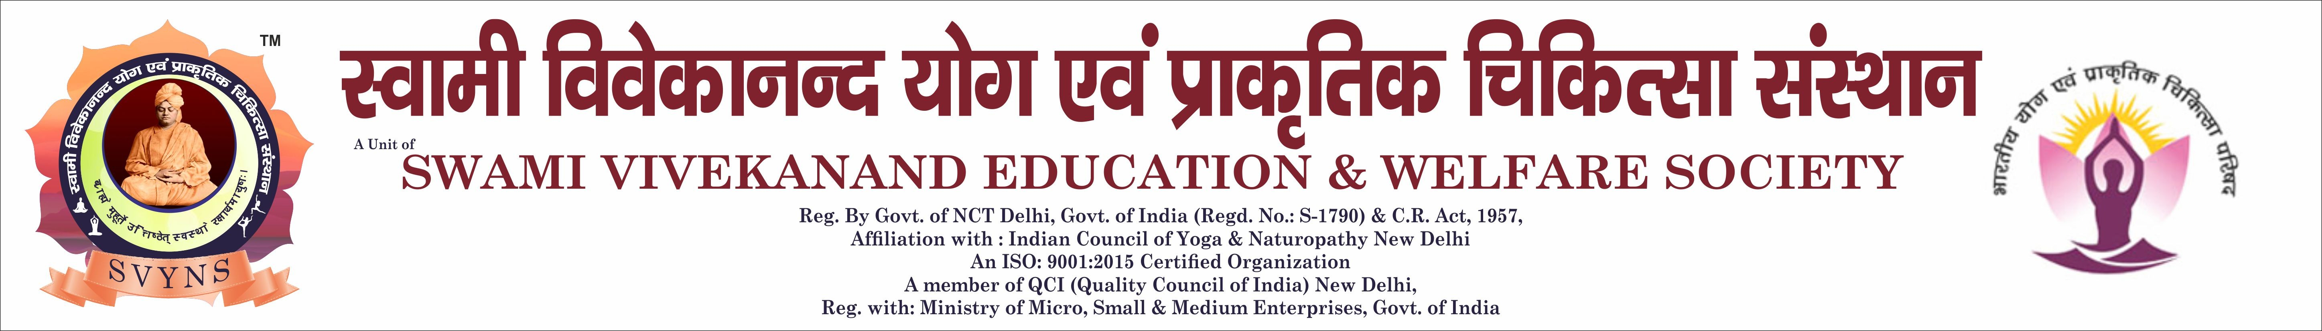

|  |  |  |  |
| --- | --- | --- | --- |
| **REGISTRATION NO : 22020239** | | |  |
| **STUDY MODE : REGULAR** | | |
| **COURSE APPLIED FOR** : DYED-(1 YEAR )-DIPLOMA IN YOGA EDUCATION | | |
| **EXAM MODE** : OFFLINE | | |
| **DEPARTMENT NAME** : FACULTY OF YOGA/NATUROPATHY | | |
| **COLLEGE NAME** : LUCKNOW EDUCATIONAL GROUP | | |
| **STUDENT NAME** | MR./ ी DHEERAJ KUMAR SAH | **MOBILE** | 9507772531 |
| **EMAIL ID** | [DHEERAJKR000097@GMAIL.COM](mailto:DHEERAJKR000097@GMAIL.COM) | **DATE OF BIRTH** | 20-03-1997 |
| **FATHER NAME** | MR./ ी LALBABU SAH | **MOTHER NAME** | MRS./ ीमती SUNAINA DEVI |
| **ADDRESS** | VILL CHANDPUR PO PS JAMOBAZAR , PINCODE: 841434 | | |
| **STATE** | BIHAR | **CITY / DISTRICT** | SIWAN |
| **ACADEMIC QUALIFICATION** | INTERMEDIATE | **AADHAAR NO** | 880419455406 |